Prime factor decomposition
Find these numbers in term of prime factors only, cross off the prime factors on the right hand side as you use them up in your final answer. You should not have any spare if you have got them all right!
25  25 = | 12  12 = | 66  66 = | 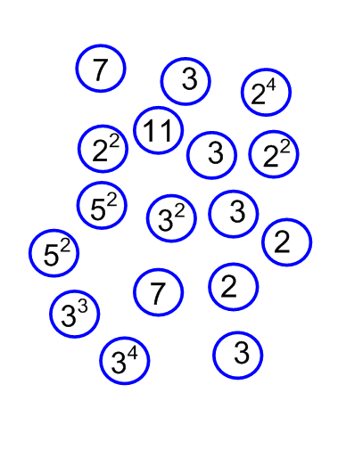
75  75 = | 21  21 = | 144  144 =
54  54 = | 81  81 = | 28  28 =
Using what you know draw a Venn diagram to find:
1) The HCF for these pairs of numbers: a) 12 and 66, b) 81 and 54, c) 25 and 75.
2) The LCM for these pairs of multiples: a) 25 and 75, b) 12 and 66 , c) 21 and 28.

Prime factor decomposition
Find these numbers in term of prime factors only, cross off the prime facctors on the right hand side as you use them up in your final answer. You should not have any spare if you have got them all right!
25  25 = | 12  12 = | 66  66 =
75  75 = | 21  21 = | 144  144 =
54  54 = | 81  81 = | 28  28 =
Using what you know draw a Venn diagram to find:
1) The HCF for these pairs of numbers: a) 12 and 66, b) 81 and 54, c) 25 and 75.
2) The LCM for these pairs of multiples: a) 25 and 75, b) 12 and 66 , c) 21 and 28.

